American Civil War
Student’s Name
Institutional Affiliation
Date

Civil war
Part I
John Smith was born on March 28, 1802 (hence turned 18 in 1820) in Wheeling, Ohio, in the U.S. state of West Virginia. This city was primarily a settlement in the British Colony of Virginia. Smith was born from a black father (John) and a white mother (Catherine). Consequently, Smith was a Black America. John and Catherine were a middle-class family as they were local farmers in the land. The entire family was slaves who worked in the cotton plantations as slaves.
Smith was born when slavery was too rampant in the southern states, including Virginia. It was a period when African Americans experienced injustice and inequality by the whites. Smith, like other African American children in the South, soon became a slave at a nearby cotton plantation. He did not get an opportunity to go to school. He also experienced all forms of injustices and discrimination and mistreatment. His color and race betrayed him.
Avatar
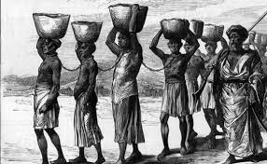
I created this avatar to show how Smith and other slaves went through difficult times. The slaves used to work in the cotton, sugarcane, and tobacco plantations in the South. The avatar shows how the slaves were mistreated and worked for their masters. Slaves were subjected to harsh working conditions like long working hours.
Part II
One of the significant historical conflicts that took place in the time period of the character was the American Civil War, which took place from 1861 to 1865. The war was fought between the northern states and seven southern states. The northern states were loyalists to the Union, while the southern states had seceded to form the Confederate States of America. The war started in April 1861, a month after Abraham Lincoln had been inaugurated as the U.S. president. The secessionists (southern states) wanted states to have the right to uphold slavery, while the northern states supported the constitution for the abolition of slavery. It is argued that the American Civil War was the deadliest war ever fought on American soil. The war lasted four years, after which the major Confederate armies surrendered to the United States.
Causes of the war
There has been a debate on the causes of civil war, which has been necessitated by the argument of including the Confederate flag to be among the state flag and also displaying it in all public places. Charles B. Dew wrote a piece of work that would be of great importance to this debate. His paper proves that there are various points of view when it comes to the issue of citizenship. Dew (2017) argues that slavery was the leading cause of the war. According to him, the northern states depended on manufacturing and industry, and agriculture was limited to a few people.
On the other hand, the southern states' economy was driven by agriculture, whereby large scale farming was practiced (Dew, 2017. Agriculture was the backbone of the economy of the southern states. These states depended on slaves for labor to work in the cotton and tobacco farms. Meanwhile, abolitionist movements started to grow in the north, and the southern states felt that their economy was in danger if slavery was to be abolished in America (Gunderson, 1974).
After the election of Abraham Lincoln as the U.S. president in November 1860, seven southern states seceded from the United States. These states were Mississippi, Florida, South Carolina, Alabama, Louisiana, Georgia, and Texas. Four more states entered the secessionist fray afterward- North Carolina, Arkansas, Virginia, and Tennessee (Parish, 2020). Border slave states such as Maryland, Kentucky, Delaware, and Missouri did not secede. Thus, slavery was the main cause of the American civil war because it brought the division between the northern and southern states. It is the secession of the southern states that brought about the war. The southern states could not do without the slaves because they depended on agriculture and needed the slaves to work in the plantations and perform other duties.
On the other hand, the northern states had nothing to lose if slavery was to be abolished because they were urbanized and did not require slaves. Apart from slavery, there were other minor causes of the war. These include the States' Rights, whereby there was a struggle between the federal government and the States over political power. The states opposed the idea that the federal government had the right to regulate or abolish slavery within individual states. The northern states supported the government in abolishing slavery, while the southern states maintained that the government did not have any right to regulate or abolish slavery. This debate widened the gap between the southern and northern states, with the former resolving to secede.
Another cause of the war was the Dred Scott Decision, which denied African-Americans citizenship and overturned the Missouri Compromise of 1820. This compromise had restricted slavery in certain parts of the United States (Parish, 2020). The election of Abraham Lincoln was also believed to worsen the situation and triggered the war. After winning the 1860 elections, Lincoln, known for his ant-slavery campaign, made the Southerners fear that he would abolish slavery. Since the southerners believed Lincoln would cooperate with the northerners in abolishing slavery, they decided to secede.
Part III
Primary source
The primary source related to the American Civil War is the emancipation proclamation. The Emancipation Proclamation, which was issued by President Lincoln on January 1, 1863, was an enduring symbol of equality and social justice. The proclamation freed slaves in rebel states and allowed freed slaves to join the Union Army (Guelzo, 2005). The document freed all slaves in the states that engaged in rebellion against the Union. The document applied only to the slaves in the Confederacy, not to those in the Border States (Maryland, Delaware, Kentucky, and Missouri) that remained loyal to the Union. The document was directed to the Southern states in rebellion. The document had enormous symbolic power and value as it announced freedom for the slaves. The document also preserved the Union. The document's symbolic value was very significant as it symbolized equality and social justice. Emancipation Proclamation was of great importance as it contributed to the end of the war on December 6, 1865, when slavery was abolished.
Examples of quotes from the Emancipation Proclamation are "that all persons held as slaves" within the rebellious states "are, and henceforward shall be free" (Lincoln, 1863). All three quotes show that the document was from an executive order of the United States president.
Smith would definitely agree with the contents of the document. This is because the document mostly touched African Americans, especially in the South. Thus, Smith would be so happy to read it as it symbolized equality and social justice, which the African Americans were denied.

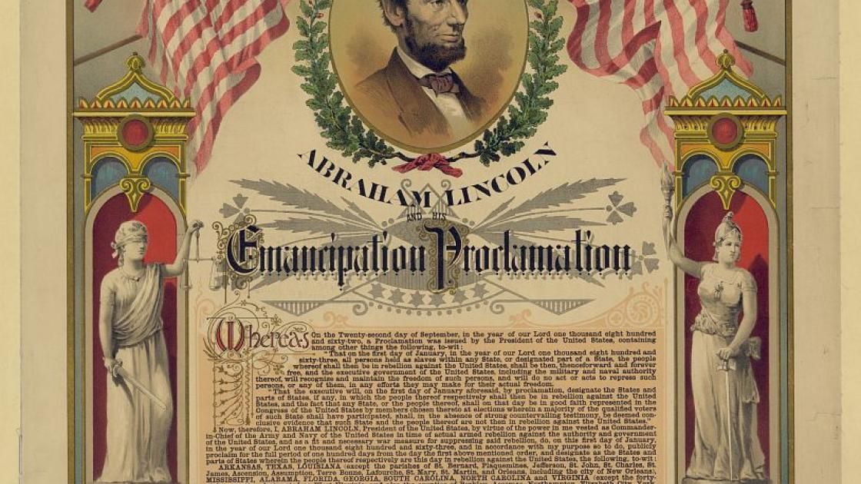Primary source: Emancipation Proclamation by President Abraham Lincoln in 1863.
Part IV: Ethical dilemma
The civil war presented an ethical dilemma to John Smith. The war tested the nationalism and patriotism of the Southerners. With the war having been fought for three years by the time the Emancipation Proclamation was issued, Smith would be in a dilemma whether to stay in Virginia (a confederate state) or move northwards and join the Union Army help fight the confederates. If Smith moves to the north, he would join the Union as a soldier or become a slave serving the Union Army. Hence, he was torn choosing between remaining in the South and moving to the north. Either way, he would not be "free" per se. Given that the proclamation didn't destroy the institution of slavery and did not free any slaves except for its symbolic value that symbolized equality and social justice, one would doubt its practical significance (Foner, 2011). Joining the Union Army or Navy was a tough choice because Smith would die as a soldier. Freedom was only guaranteed if the Union (United States) won the war. This was another form of slavery because joining the Union came with its fair share of problems. The moral dilemma is that whether in the South or north, Smith would still be a slave.
Part V
The character (Smith) decided to join the Union Army and fight the confederate states. Smith was among the 200,000 African-Americans who served in the Union Army and navy at the end of the war (Keegan, 2011). The emancipation proclamation helped African-Americans to fight for their freedom. Smith turned from being liberated to being a liberator. Joining the army was a moral choice by Smith that injustice in one place is injustice everywhere. Smith agreed to work with the federal government to end slavery in the South. Being a black American and having experienced the brutality of slavery and the injustice meted against the African Americans, Smith could not help himself but join the Union Army to ensure slavery is wholly abolished. Historically, it would be expected for Black Americans to join the Union Army to ensure that slavery came to an end. This is because black Americans felt the impact of social injustice the most. Again Smith played his civic responsibility of promoting justice and patriotism. Smith knew that winning the war would lead to abolishing slavery, which every African American dreamt about. Having served as a slave in Virginia, Smith had felt the impacts of slavery and social marginalization. He also felt the effects of racial discrimination and prejudice. Thus, he could not resist joining the Union Army for all this to come to an end.
Part VI
Smith believed in justice and equality; that is why he joined the Union Army as one of the soldiers. He was determined to free any other slave in the confederate state. Virginia was one of the states where slavery was rampant, and Smith experienced it from his boyhood. Smith understood that he needed freedom at all costs. This made him make a firm decision to join the Union and denouncing the Southern states. The war tested his nationalism and national allegiance. During the 10th century, nationalism was a powerful force. The northerners practically supported the Union while the Southerners were split between those loyal to the federal government (United States) and those loyal to the Confederacy. Smith, being a southerner, was among those stuck whether to remain faithful to the entire United States and denounce the Southern region or remain loyal to the southern region and denounce the Unionists. Due to the circumstances that had befallen Smith (being a slave and a black American), the best option was to join the Unionists and liberated the rest of the slaves. The Emancipation Proclamation allowed him to join the army and fight against slavery in the South. His decision bore fruits when the unionists defeated the southern states in April of 1865, effectively bringing the bloody war to an end.

References
Dew, C. B. (2017). Apostles of disunion: Southern secession commissioners and the causes of the Civil War. University of Virginia Press.
Foner, E. (2011). The fiery trial: Abraham Lincoln and American slavery. WW Norton & Company.
Guelzo, A. C. (2005). Lincoln's Emancipation Proclamation: The end of slavery in America. Simon and Schuster.
Gunderson, G. (1974). The Origin of the American Civil War. The Journal of Economic History, 34(4), 915-950.
Keegan, J. (2011). The American Civil War. Random House.
Lincoln, A. (1863). The emancipation proclamation. September 22, 1862.
Parish, P. J. (2020). The American civil war. Routledge.

